Name : Prajwal Weladi

Class : CSAI-A

Roll no. : 53

Prn. : 12210360

# **Lab Assignment 4**

1.Write Shell script to find out positive and negative numbers from accepted array.Assume

Array consists of 5 numbers.Also accept array from user.

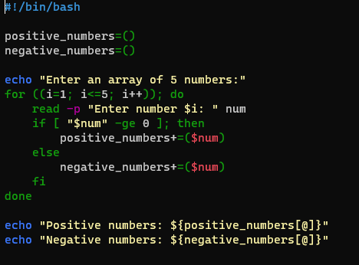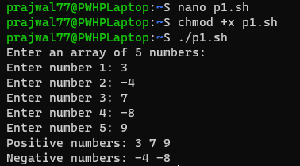

2.Write Shell script to find out even and odd numbers from accepted array.Assume Array

consists of 5 numbers. Also accept arrays from users.

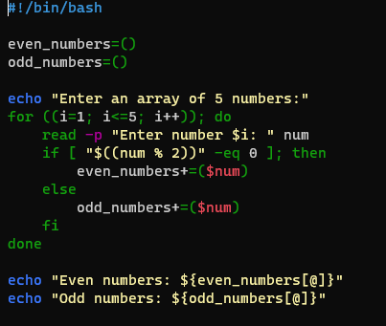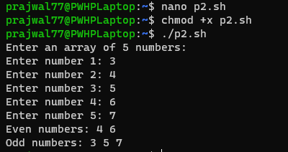

3.Write Shell script to sort array numbers ascending and descending order.Assume Array

consists of 5 numbers. Also accept arrays from users.

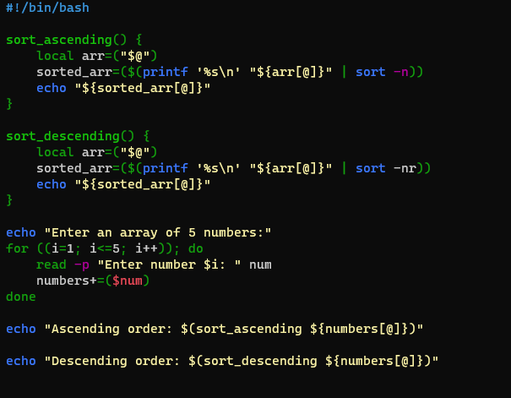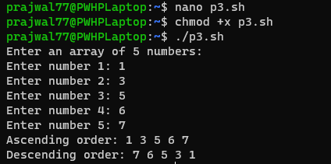

4.Write Shell script to find out smallest number and largest number of given array.Assume

Array consists of 5 numbers. Also accept arrays from users.

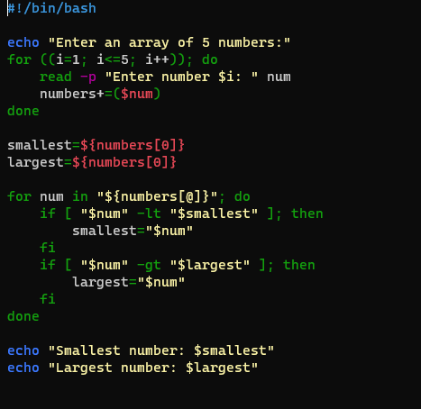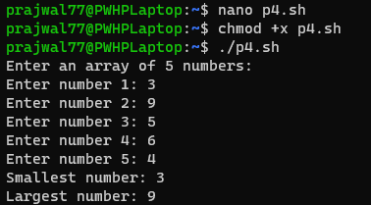

5.Write shell script to find out the reverse number of a given number.

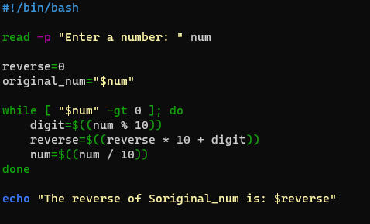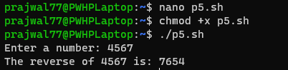

6.Write a shell script to create a fibonacci series.

